**Project Design Phase-II**

**Technology Stack (Architecture & Stack)**

**Technical Architecture:**

The Deliverable shall include the architectural diagram as below and the information as per the table1 & table 2

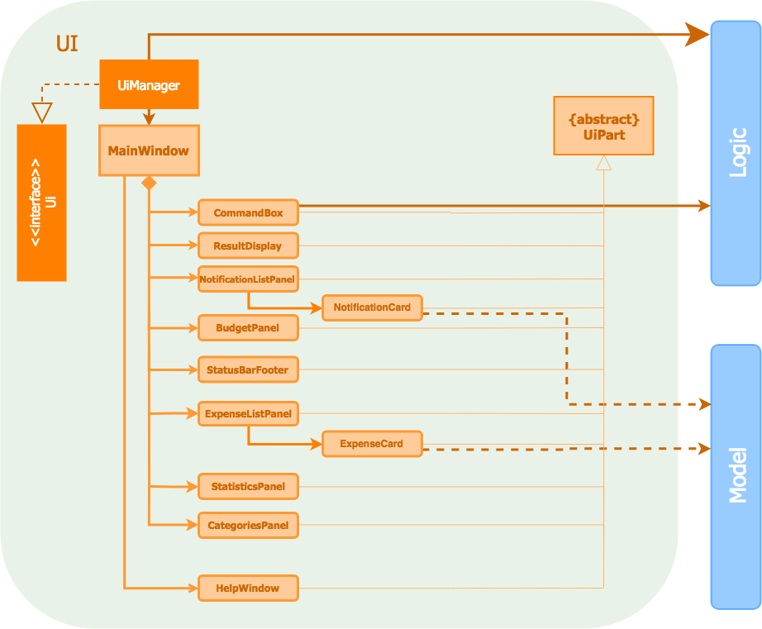

**Table-1 : Components & Technologies:**

|  |  |  |  |
| --- | --- | --- | --- |
| **S.No** | **Component** | **Description** | **Technology** |
|  | User Interface | For user onboarding such as Login and Dashboard functions | HTML, CSS, JavaScript. |
|  | Application Logic-1 | The application contains the sign in/sign up where the user will login into the main dashboard. | Java / Python |
|  | Application Logic-2 | Dashboard contains the fields like add income, add expenses, save money. | IBM Watson STT service |
|  | Application Logic-3 | The user will get the expense report in the graph form and also get alerts if the expense limit exceeds. | IBM Watson Assistant |
|  | Database | The income and expense data are stored in the MySQL database. | MySQL, NoSQL, etc. |
|  | Cloud Database | With use of database services on cloud, the user data are stored in a well secured manner. | IBM DB2, IBM Cloudant etc. |
|  | File Storage | IBM block storage used to store the financial data of the user. | IBM Block Storage or Other Storage Service or Local Filesystem |

**Table-2: Application Characteristics:**

| **S.No** | **Characteristics** | **Description** | **Technology** |
| --- | --- | --- | --- |
|  | Open-Source Frameworks | Flask Framework in python is used to implement this application. | Python-Flask |
|  | Security Implementations | This application provides high security to the user financial data. It can be done by using the container registry in IBM Cloud. | Container Registry, Kubernetes Cluster. |
|  | Scalable Architecture | Expense Tracker is a life time access supplication. Its demand will increase when the users income are high. | Container Registry, Kubernetes Cluster |
|  | Availability | This application will be available to the user at any part of time. | Container Registry, Kubernetes Cluster |
|  | Performance | The performance will be high because there will be no network traffics in the application. | Kubernetes Cluster |